**Lab 6: Using HDFS Access Control Lists**

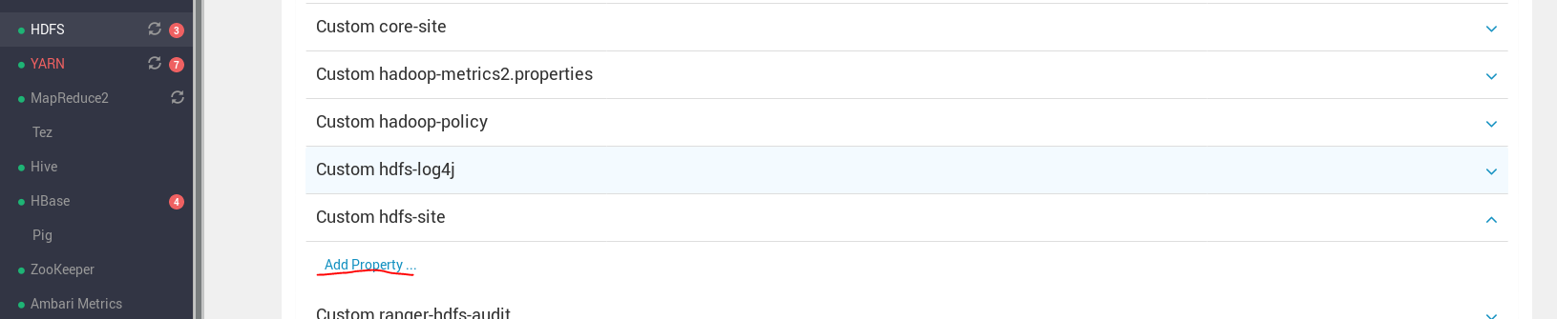

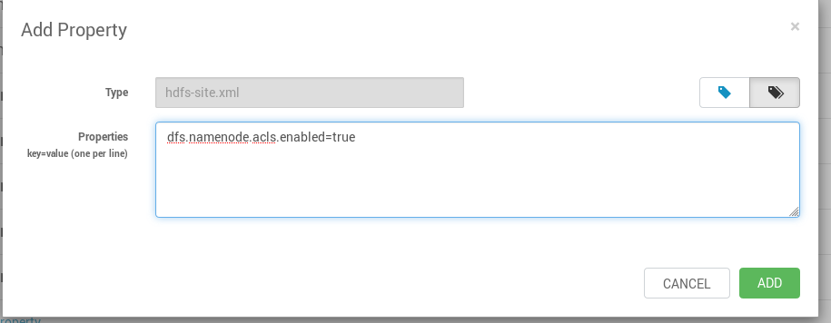

Create a test directory named /acltests. All testing of HDFS ACLs will occur in this directory. You must become the HDFS superuser to configure the test environment.

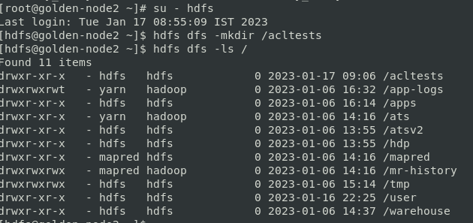

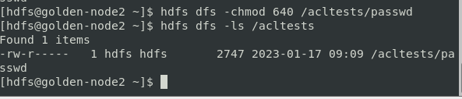

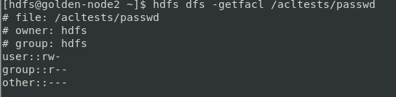

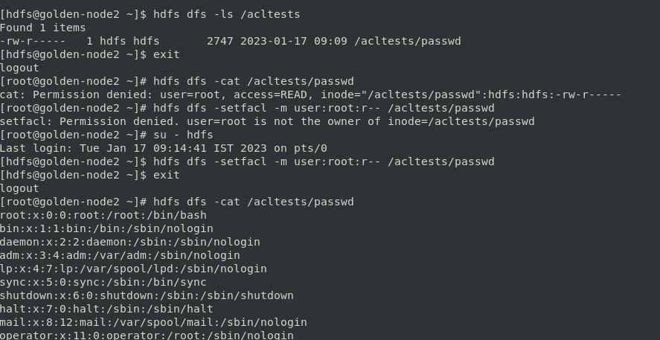

Add another ACL entry to the /acltests/passwd file. This time provide the group hcat read and write access to the file. Verify the change once you have added the new ACL entry.

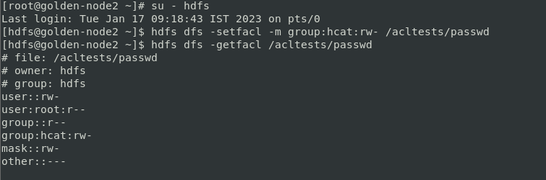

.Remove the ACL entry for the group hcat from the /acltests/passwd file. Verify the change once you have removed the ACL entry.

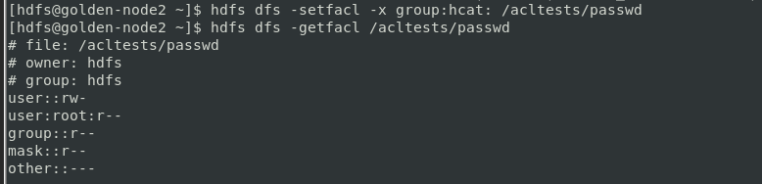

Use the HDFS Shell *-setfacl* command with the *--set* option to completely remove and replace the entire set of ACL entries. Verify the change once you have finished

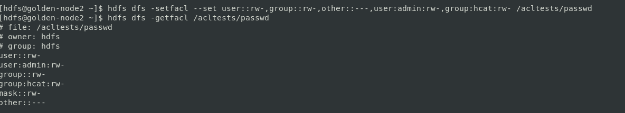

Remove all ACL entries from the /acltests/passwd file. Verify the removal when you have finished.

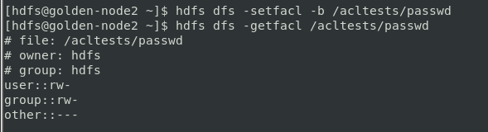

**Managing Directory ACLs**

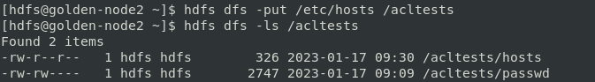

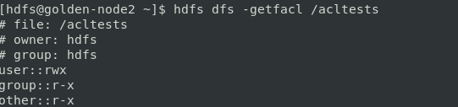

Add a default ACL entry for the root user to the /acltest directory. The default ACL entry should provide the root user with read and write permissions. Verify the changes once you have finished.

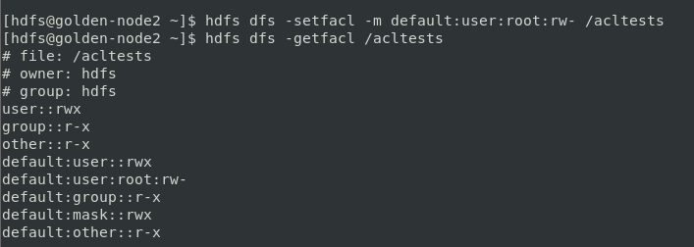

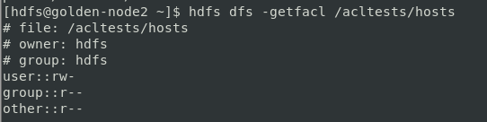

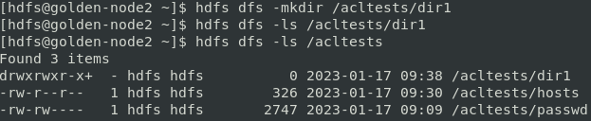

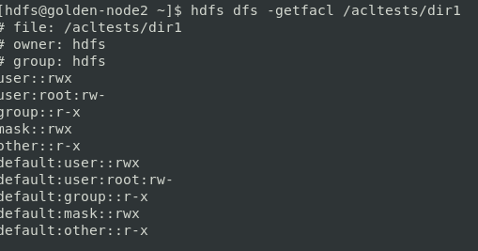

**Managing Access Using an Access Mask**

While you still have HDFS superuser permissions, change the access mask for /acltests/hosts so that the unnamed group or any specific user or groups cannot read the hosts file. Verify the change once you have finished.

